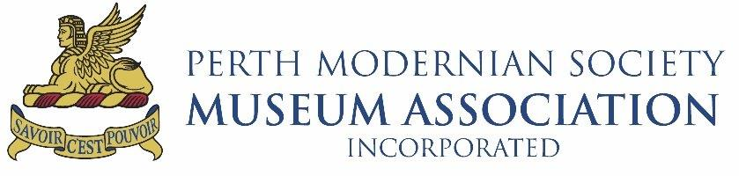

BIOGRAPHICAL INFORMATION
Note: The form below can be printed, filled in and mailed to:
Perth Modernian Society MUSEUM ASSOCIATION Inc., c/o Perth Modern School, 90 Roberts Road, Subiaco, WA 6008 AUSTRALIA (or Fax to (08) 9380 0550) or scanned and emailed to museum@perthmoderniansociety.org.au.
BIOGRAPHICAL INFORMATION is sought for inclusion in the archives of the Historical and Museum Committee to facilitate enquiries by former students and staff, family members and other approved researchers.
If you have not already done so please register with the Society using the online Membership Form.
Registration is free or you can become a Contributing Member for only $40.00 per annum.

Please note: Completion of details will be considered permission to publish

Family name at school
Family name now
Given names
Title (eg Mrs, Dr, Prof, etc) | Initials | Preferred Name

Postal Address
 | Town/Suburb |  | Postcode
 | Country

Telephone | Home: | Work:
Mobile
e-Mail

SCHOOL YEARS | Entry Year | Final Year
Year (eg 1995)
Level (eg Year 8)

YEARS ON STAFF | First year | Last Year
First Appointment
Second Appointment

Primary School(s)
Year and Place of Birth
Secondary School
Suburb/Town of Family Home during time at PMS
Entrance Qualification
Other Entrance Qualification (If applicable)
Faction/House
 | See overleaf …
PMS Highlights**
Further Education**
(uni, tech college, etc)
Current Occupation**
Degrees or Other Qualifications**

Occupation(s) on leaving School or after subsequent education
Career Highlights**
Lifetime Achievements
Name of Person providing this information |  |  | Relationship to Ex-Student *
Telephone Number * |  | Email Address
Other family members who attended Mod (show years)
Permission to Publish | I give my permission to publish the items marked **.  Signature:

